**DBMS LAB TASK-5**

**Name: Kommaraju Jahnavi**

**Reg No. : 121910306007**

**Section: B6**

**SAILORS DATABASE**

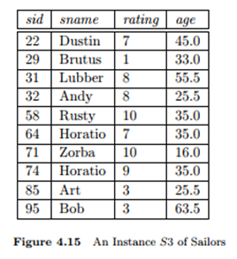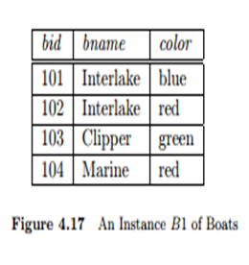

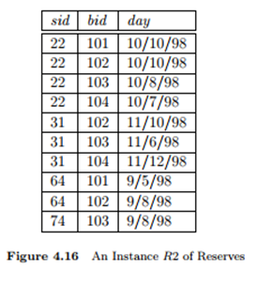

1. **CONSTRUCT AN ER MODEL FOR SAILORS DATABASE WITH CONSTRAINTS**

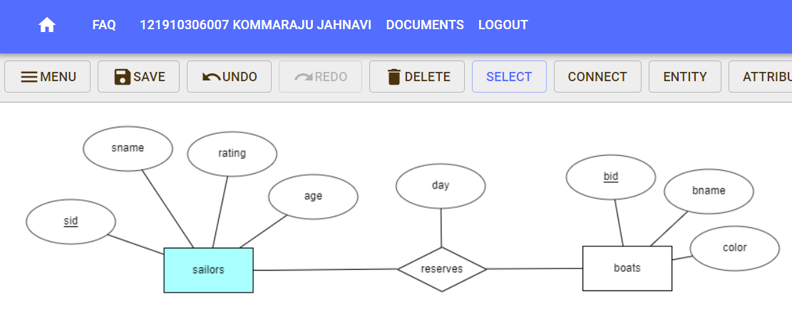

1. **CREATE A TABLES FOR SAILORS DATABASE WITH CONSTRAINTS**

**For SAILORS Table:**

**CREATE TABLE SAILORS(SID INTEGER PRIMARY KEY, SNAME VARCHAR(10) NOT NULL, RATING INTEGER, AGE INTEGER);**

**Output:**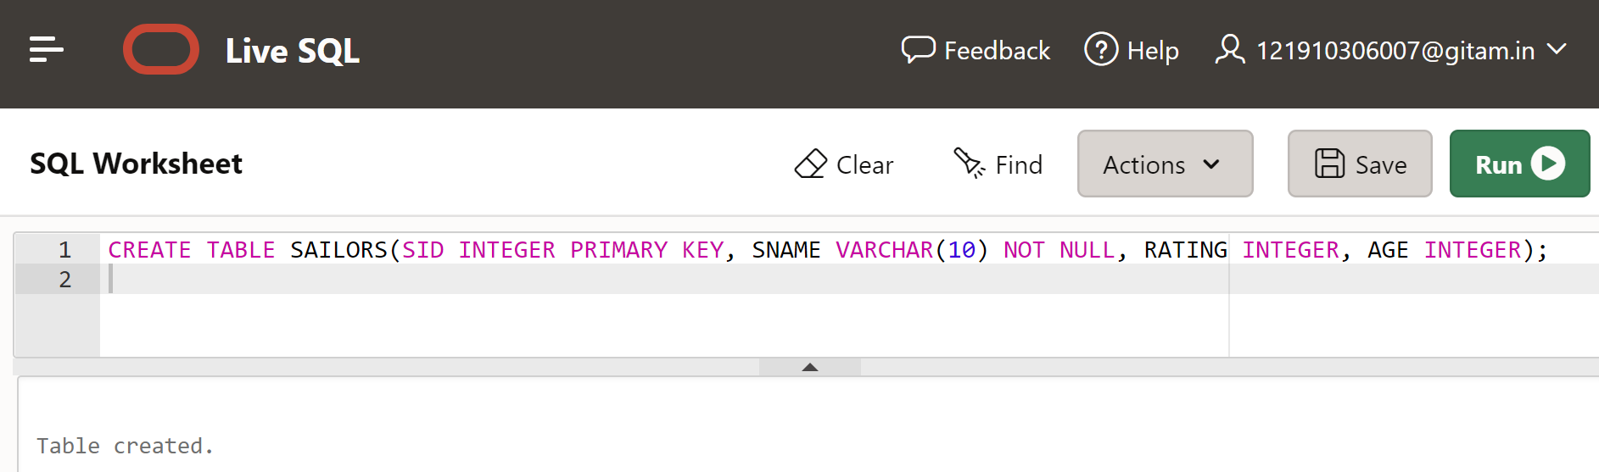

**For BOATS Table:**

**CREATE TABLE BOATS(BID INTEGER PRIMARY KEY,BNAME VARCHAR(10) NOT NULL,COLOR VARCHAR(10));**

**Output:**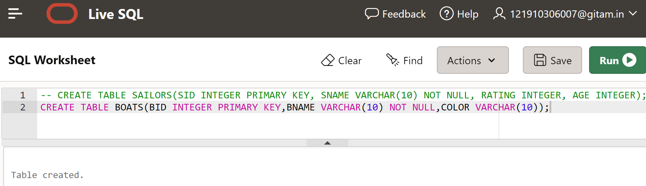

**For RESERVES Table:**

**CREATE TABLE RESERVES(SID INTEGER , BID INTEGER,DAY DATE NOT NULL,PRIMARY KEY(SID,BID),**

**FOREIGN KEY (SID) REFERENCES SAILORS,FOREIGN KEY (BID) REFERENCES BOATS);**

**Output:**

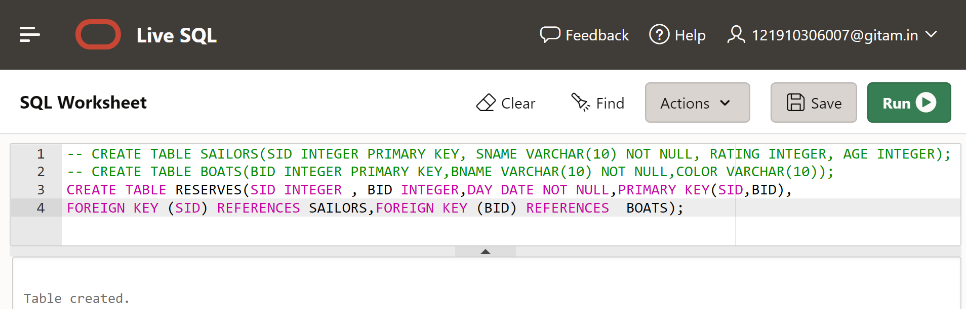

1. **INSERT THE VALUES IN RELATIONS**

**For SAILORS Table:**

INSERT INTO SAILORS VALUES(22, 'Dustin', 7, 45.0);

INSERT INTO SAILORS VALUES(29, 'Brutus', 1, 33.0);

INSERT INTO SAILORS VALUES(31, 'Lubber', 8, 55.5);

INSERT INTO SAILORS VALUES(32, 'Andy', 8, 25.5);

INSERT INTO SAILORS VALUES(58, 'Rusty', 10, 35.0);

INSERT INTO SAILORS VALUES(64, 'Horatio', 7, 35.0);

INSERT INTO SAILORS VALUES(71, 'Zorba', 10, 16.0);

INSERT INTO SAILORS VALUES(74, 'Horatio', 9, 35.0);

INSERT INTO SAILORS VALUES(85, 'Art', 3, 25.5);

INSERT INTO SAILORS VALUES(95, 'Bob', 3, 63.5);

**Output:**

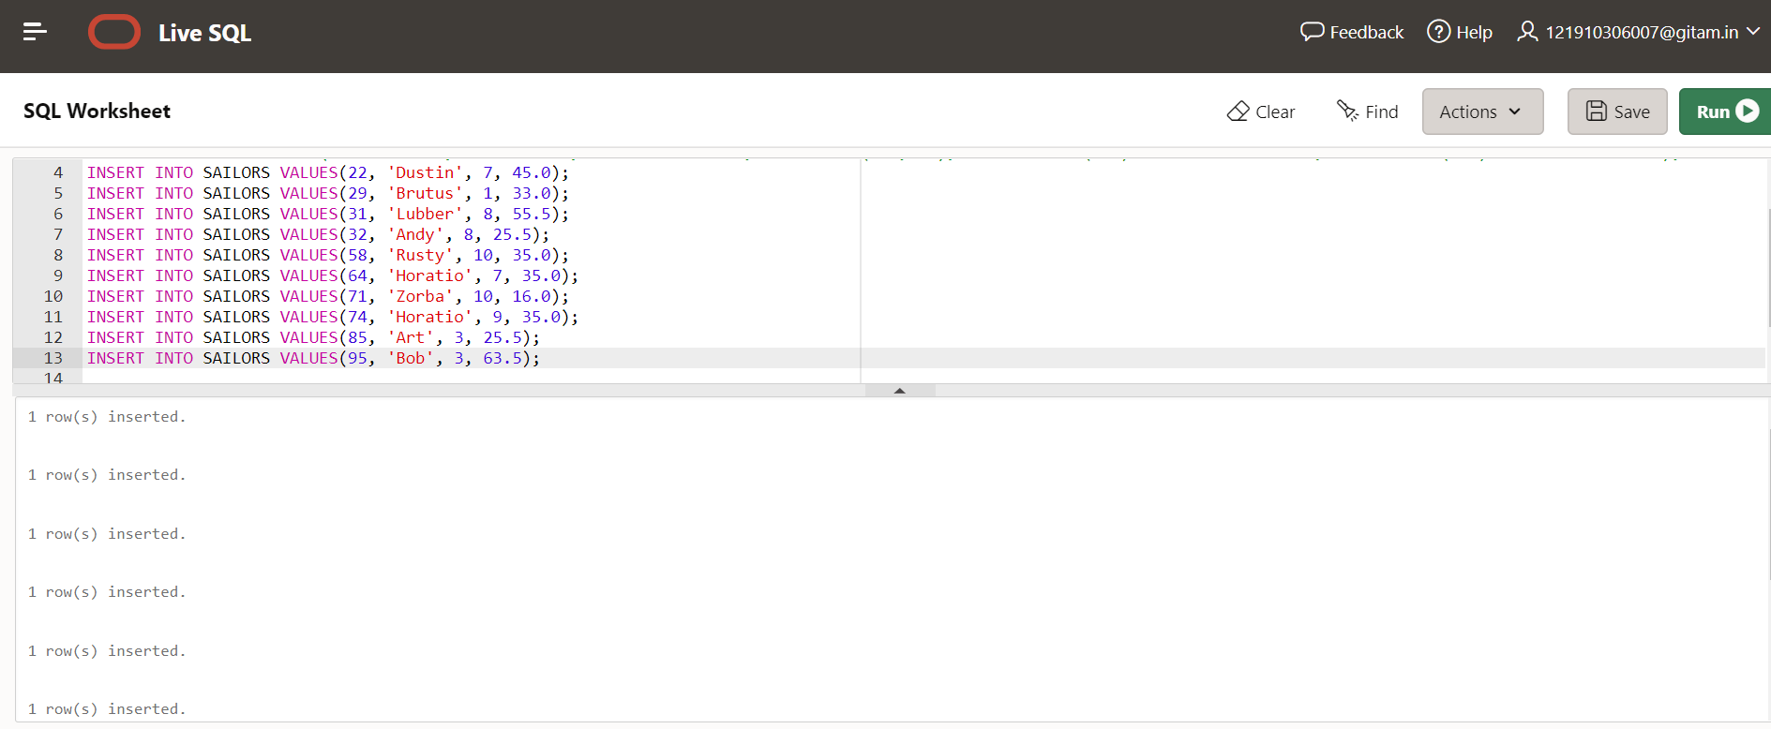

**For BOATS table:**

INSERT INTO BOATS VALUES(101,'interlake','blue');

INSERT INTO BOATS VALUES(102,'interlake','red');

INSERT INTO BOATS VALUES(103,'clipper','green');

INSERT INTO BOATS VALUES(104,'marine','red');

**Output:**

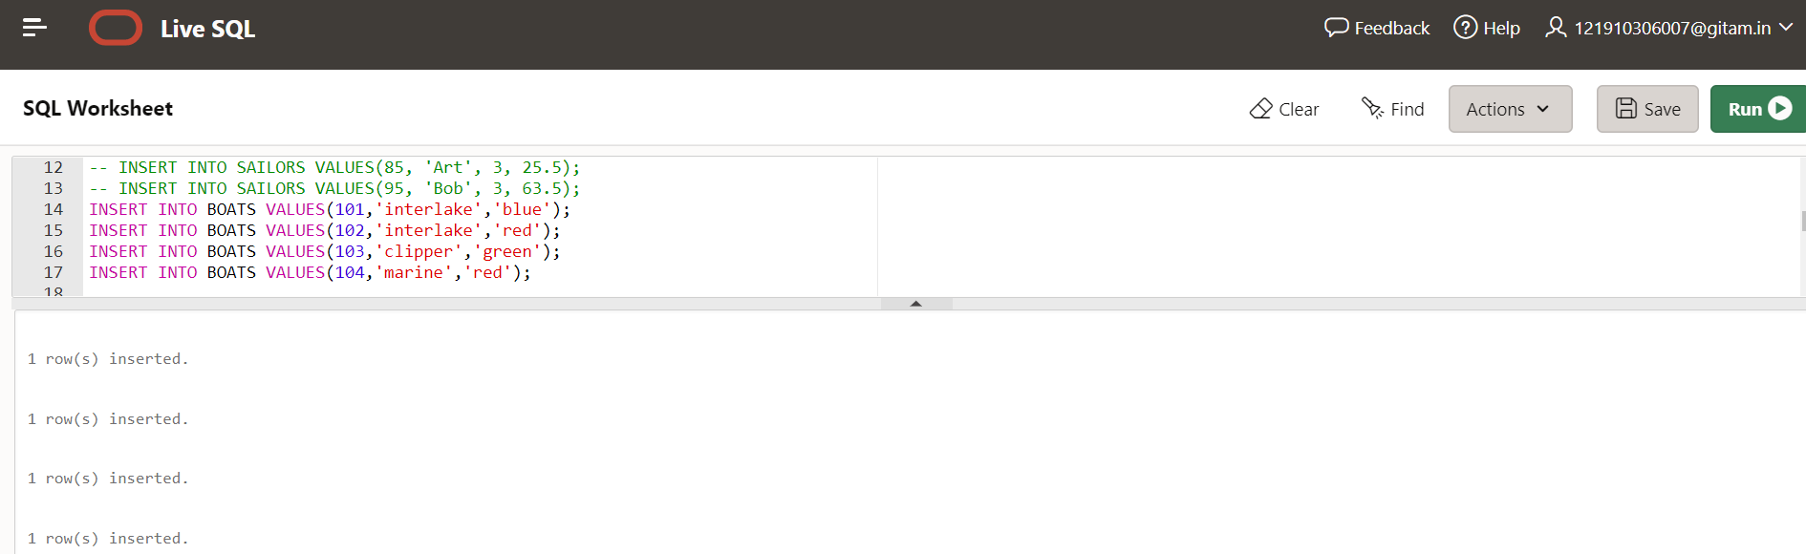

**For RESERVES table:**

INSERT INTO RESERVES VALUES(22, 101, '10/OCT/98');

INSERT INTO RESERVES VALUES(22, 102, '10/OCT/98');

INSERT INTO RESERVES VALUES(22, 103, '10/AUG/98');

INSERT INTO RESERVES VALUES(22, 104, '10/JULY/98');

INSERT INTO RESERVES VALUES(31, 102, '11/OCT/98');

INSERT INTO RESERVES VALUES(31, 103, '11/JUNE/98');

INSERT INTO RESERVES VALUES(31, 104, '11/DEC/98');

INSERT INTO RESERVES VALUES(64, 101, '9/MAY/98');

INSERT INTO RESERVES VALUES(64, 102, '9/AUG/98');

INSERT INTO RESERVES VALUES(74, 103, '9/AUG/98');

**Output:**

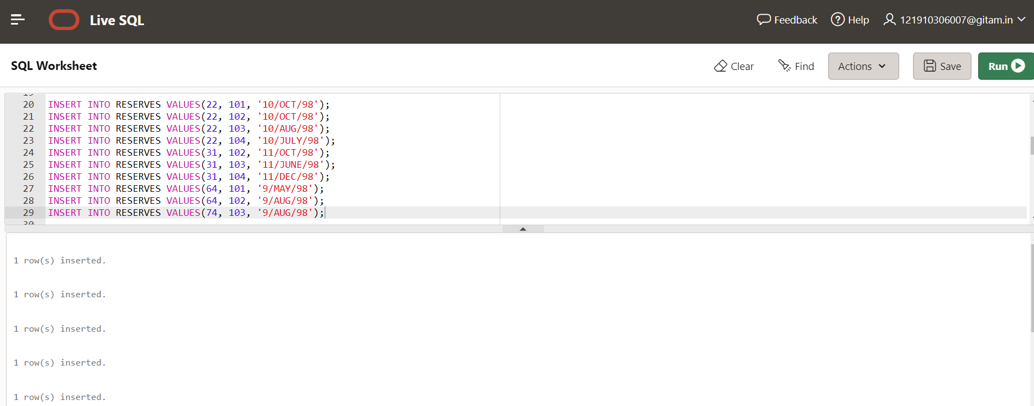

1. **DISPLAY THE RELATIONS**

**For SAILORS table:**

**SELECT * FROM SAILORS;**

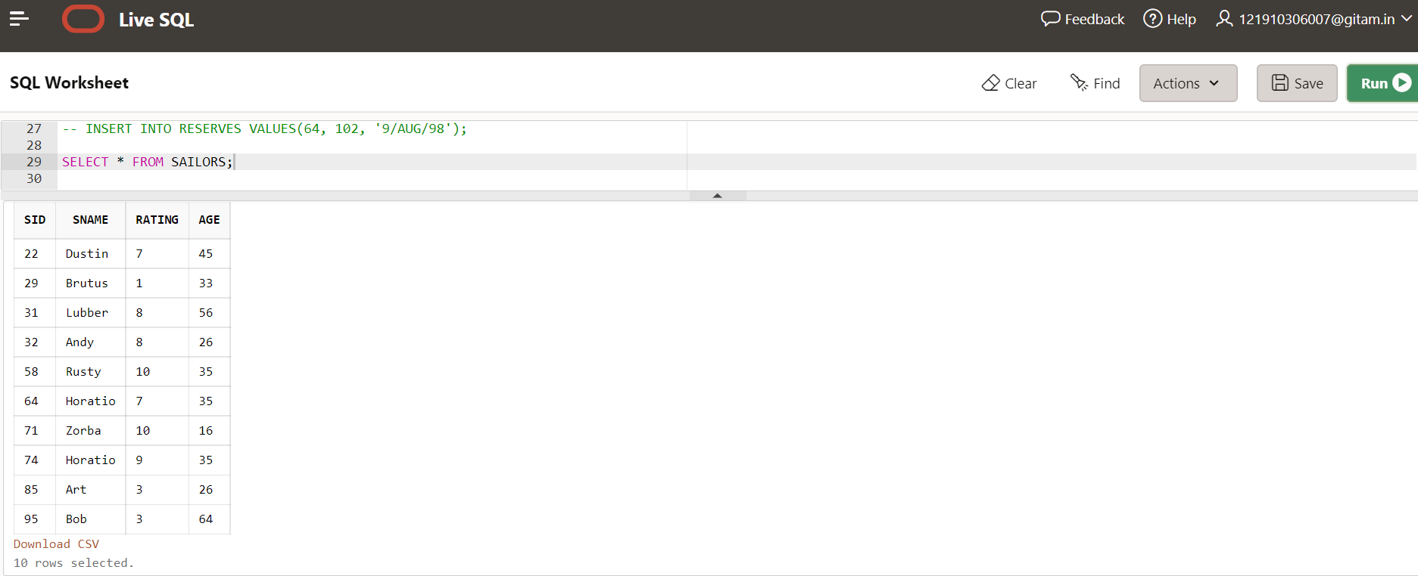

**For BOATS table:**

**SELECT * FROM BOATS;**

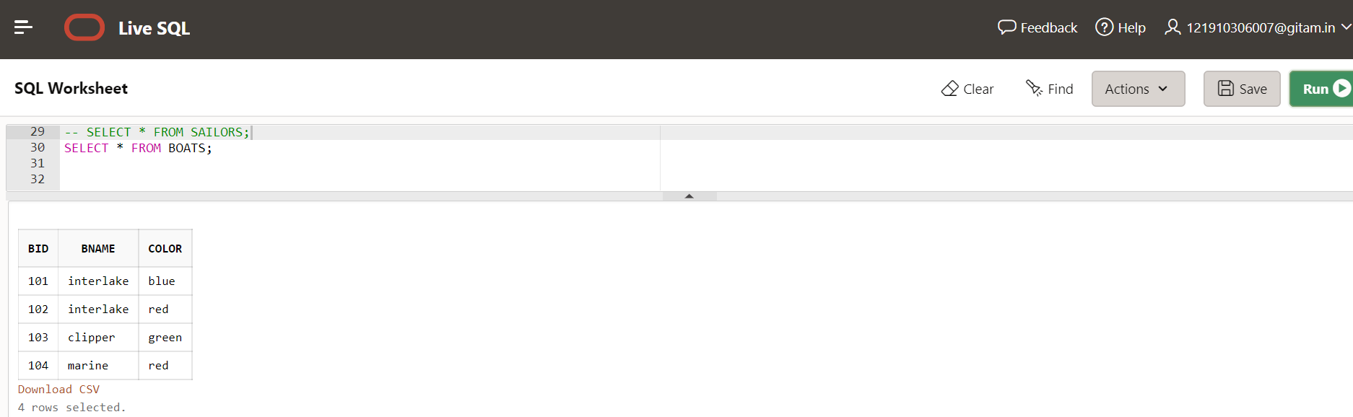

**For RESERVES table:**

**SELECT * FROM RESERVES;**

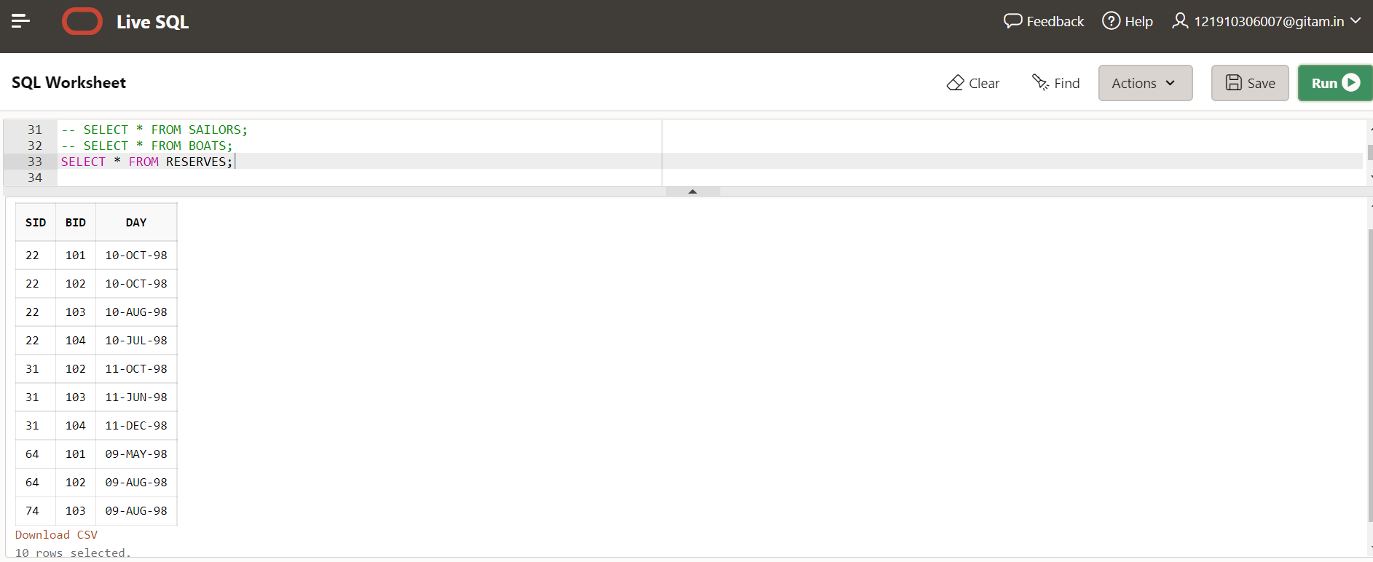

**QUERIES**

**NESTED QUERIES**

1. **Find the Names of sailors who have reserved boat 103.**

**SELECT SNAME FROM SAILORS**

**WHERE SID IN (SELECT SID FROM RESERVES WHERE BID=103);**

**Output:**

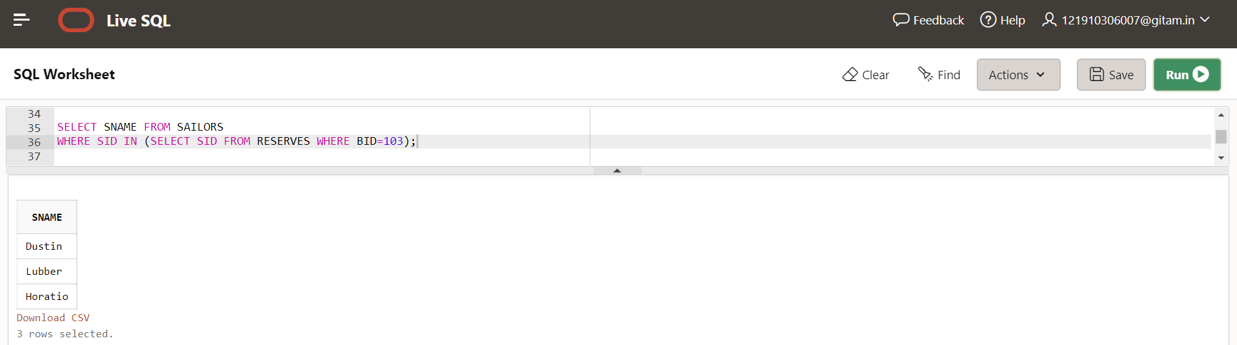

**2) Find the Names of sailors who have reserved a Red Boat**

**SELECT DISTINCT SNAME**

**FROM SAILORS**

**WHERE SID IN (SELECT SID FROM RESERVES R, BOATS B WHERE B.COLOR ='red');**

**Output:**

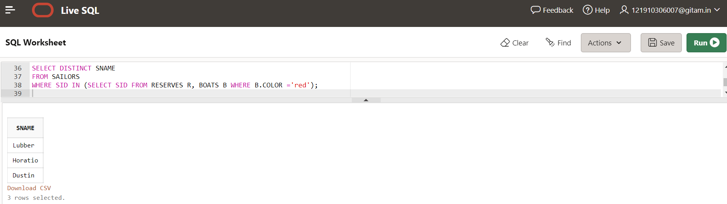

**3)Find the Names of sailors who have not reserved a Blue Boat**

**SELECT DISTINCT SNAME**

**FROM SAILORS**

**WHERE SID NOT IN (SELECT SID FROM RESERVES R, BOATS B WHERE B.COLOR='blue');**

**Output:**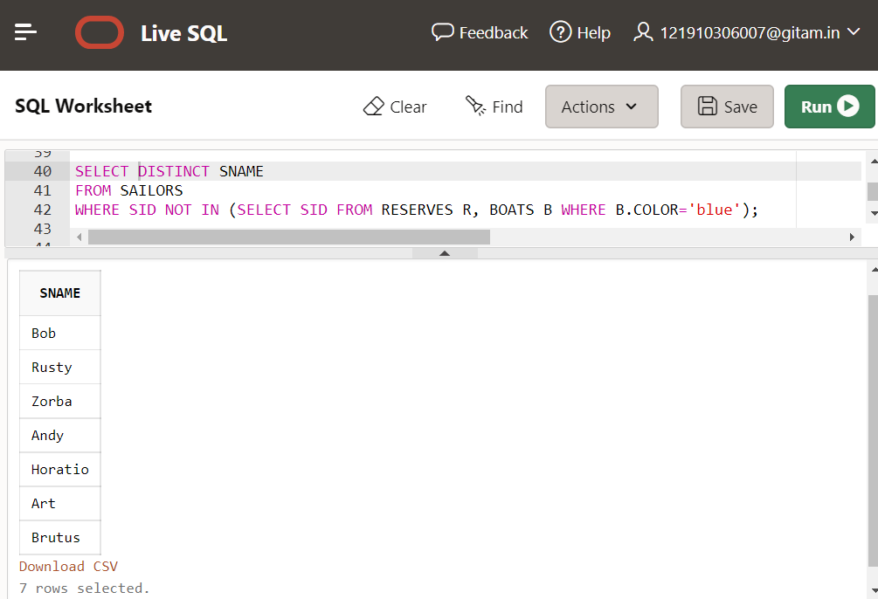

**4)Find the Names of sailors who have reserved both a Red and Green Boat.**

**SELECT DISTINCT SNAME**

**FROM SAILORS WHERE SID IN ((SELECT SID FROM RESERVES R, BOATS B**

**WHERE B.COLOR ='red') INTERSECT**

**(SELECT SID FROM RESERVES R, BOATS B WHERE B.COLOR ='green'));**

**Output:**

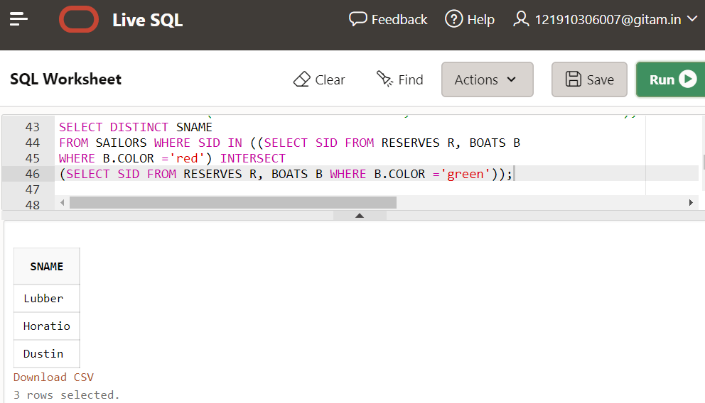

**CORRELATED QUERIES**

1. **Find the Names of sailors who have reserved boat number 103**

**SELECT S.SNAME FROM SAILORS S WHERE EXISTS(SELECT**

**\* FROM RESERVES R WHERE R.BID=103 AND R.SID=S.SID);**

**Output:**

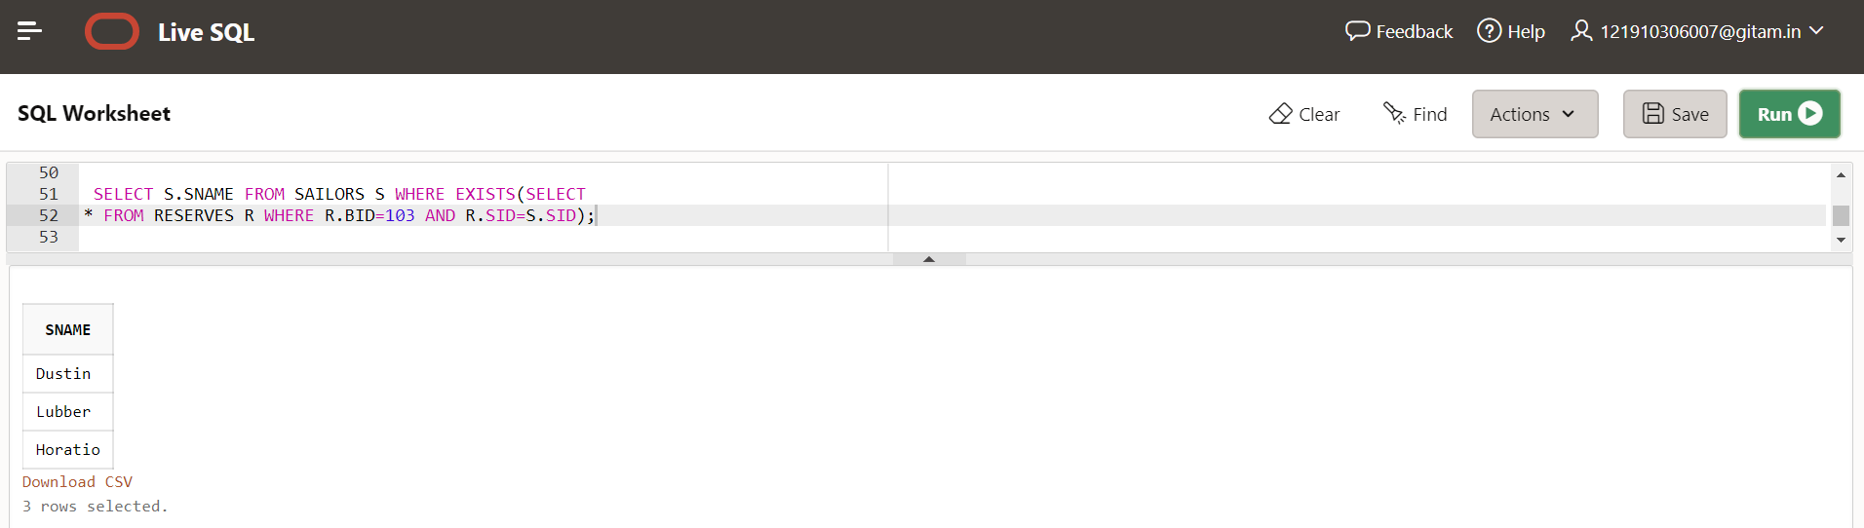

**2)Find the Names of sailors who have reserved all boats.**

**SELECT S.SNAME FROM SAILORS S WHERE NOT**

**EXISTS(SELECT * FROM BOATS B WHERE NOT EXISTS**

**(SELECT * FROM RESERVES R WHERE R.BID=B.BID AND**

**R.SID=S.SID));**

**Output:**

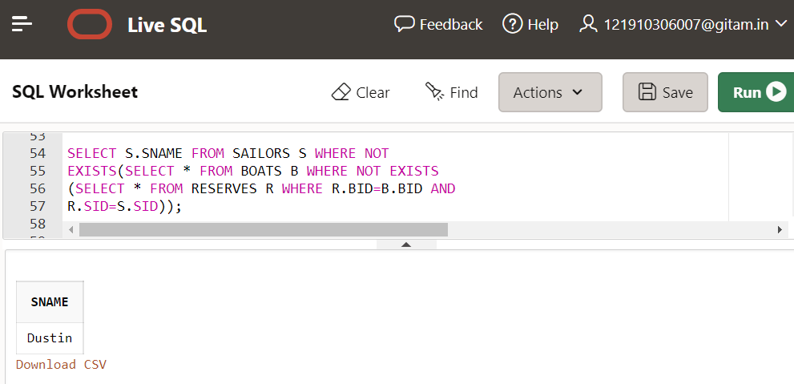

**3)Find the Names of sailors who have not reserved Boat Number 105.**

**SELECT S.SNAME**

**FROM SAILORS S**

**WHERE NOT EXISTS(SELECT * FROM RESERVES R WHERE R.BID=105 AND R.SID=S.SID);**

**Output:**

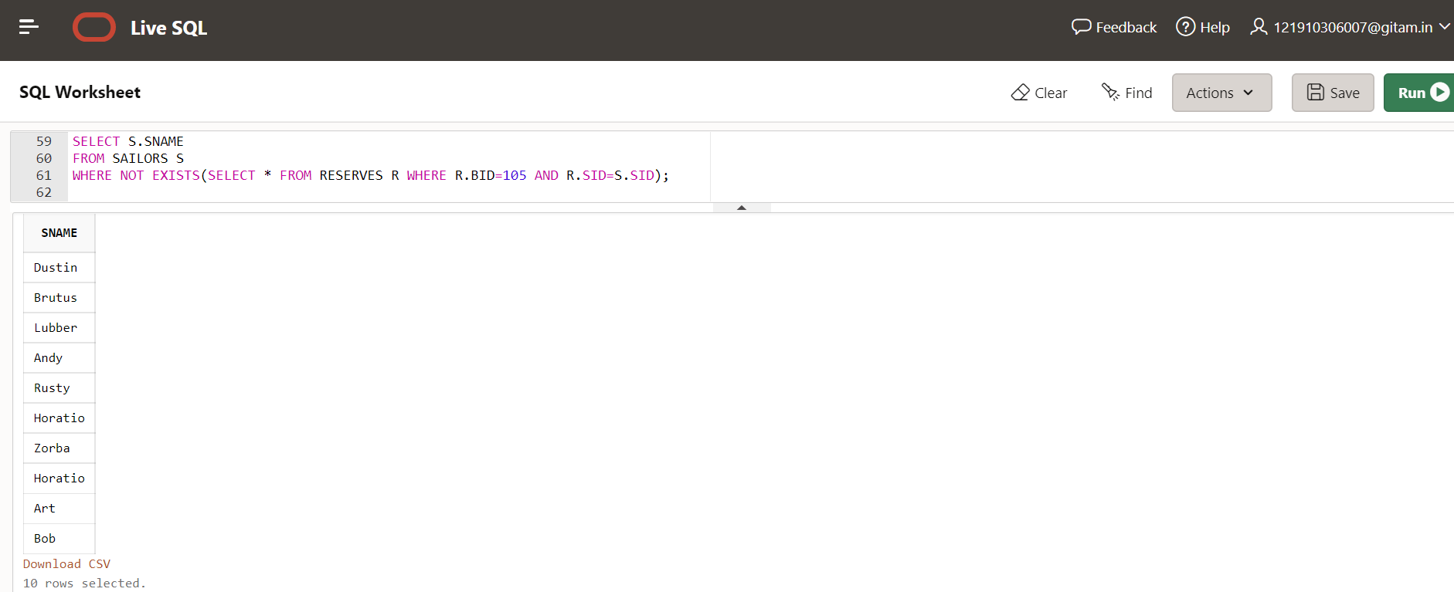

**SET COMPARISON OPERATOR**

1. **Find the sailors whose rating is better than every sailor called Horatio?**

**SELECT S.SID FROM SAILORS S WHERE S.RATING>ALL(SELECT S2.RATING FROM SAILORS S2 WHERE S2.SNAME='Horatio');**

**Output:**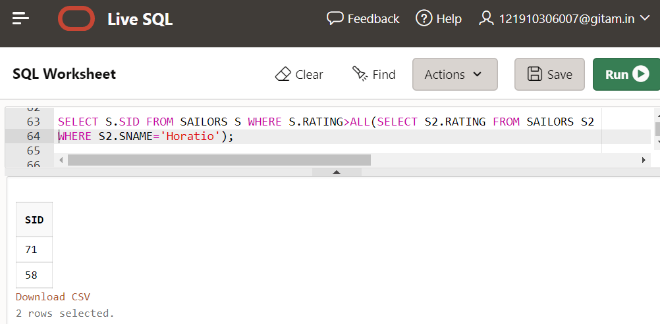

**2)Find the sailors whose rating is better than some sailor called Horatio?**

**SELECT S.SID FROM SAILORS S WHERE**

**S.RATING>ANY(SELECT S2.RATING FROM SAILORS S2**

**WHERE S2.SNAME='Horatio')**

**Output:**

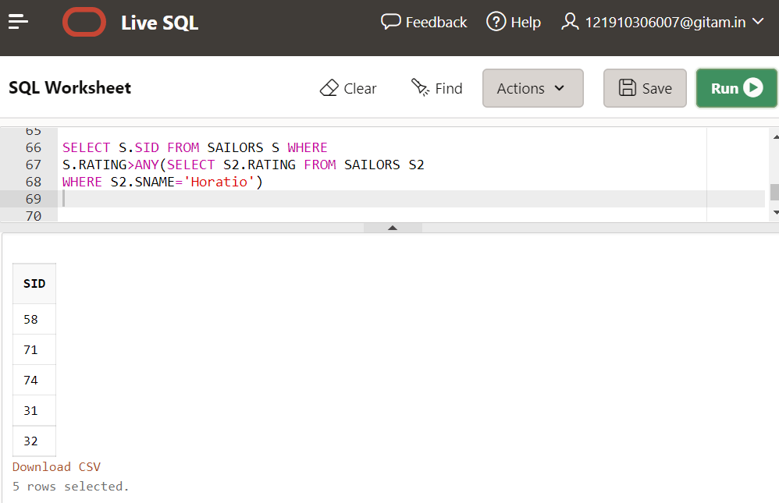

**3)Find the sailors with the Highest Rating?**

**SELECT S.SID FROM SAILORS S WHERE**

**S.RATING>=ALL(SELECT S2.RATING FROM SAILORS S2);**

**Output:**

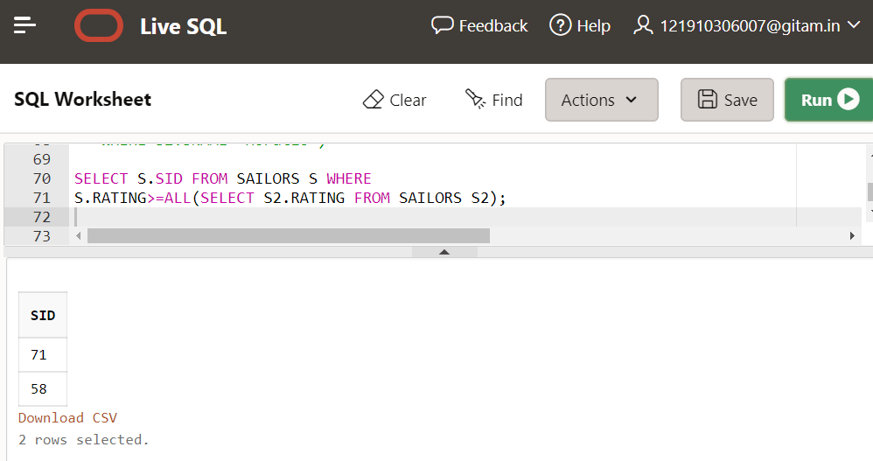

**AGGREGATE OPERATORS**

1. **Find the Name and age of the oldest sailor?**

**SELECT S.SNAME,S.AGE**

**FROM SAILORS S**

**WHERE S.AGE=(SELECT MAX(S2.AGE) FROM SAILORS S2)**

**Output:**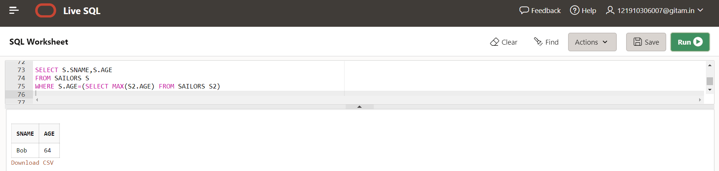

**2)Find the Names of sailors who are older than the oldest sailor with a rating of 10.**

**SELECT S.SNAME,S.AGE FROM SAILORS S WHERE**

**S.AGE>(SELECT MAX(S2.AGE) FROM SAILORS S2 WHERE**

**S2.RATING=10)**

**Output:**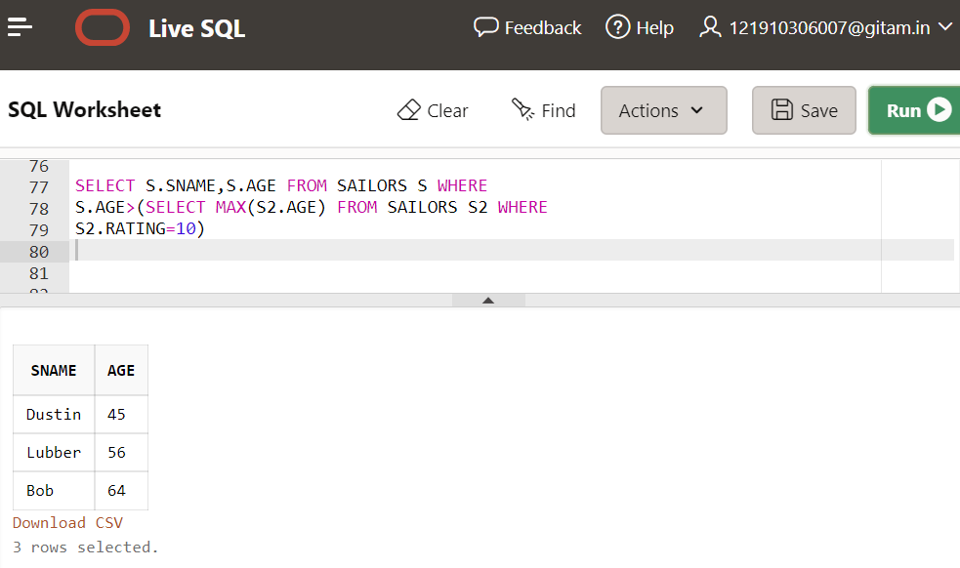

**3)Count the Number of different sailors Names?**

**SELECT COUNT(DISTINCT S.SNAME) FROM SAILORS S;**

**Output:**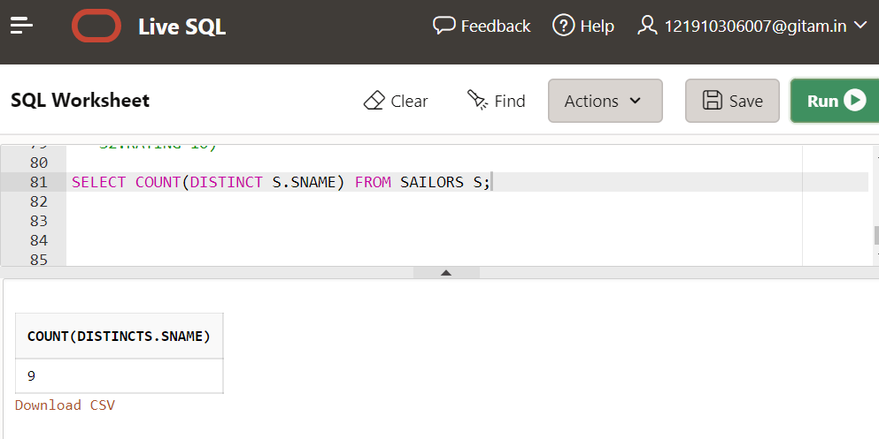

**4)Find the average age of sailors with a rating of 10?**

**SELECT AVG(S.AGE) FROM SAILORS S WHERE S.RATING=10;**

**Output:**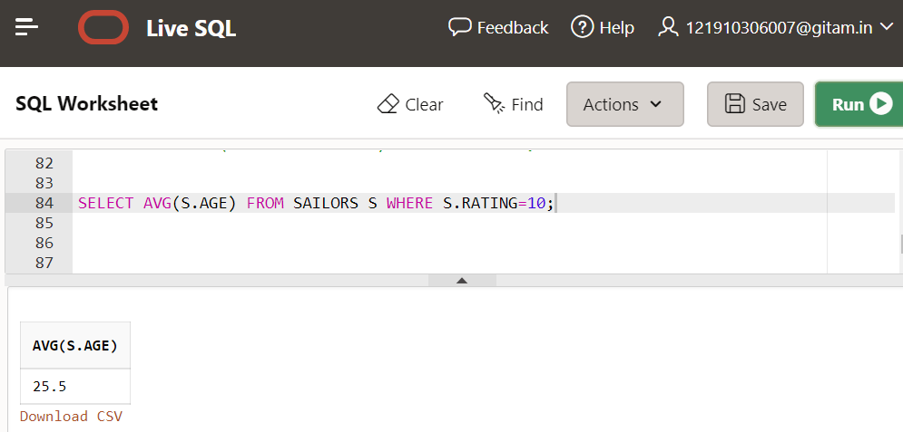

**5)Find the names of the sailors with exact 3 letters?**

**SELECT S.SNAME FROM SAILORS S WHERE LENGTH(S.SNAME)=3;**

**Output:**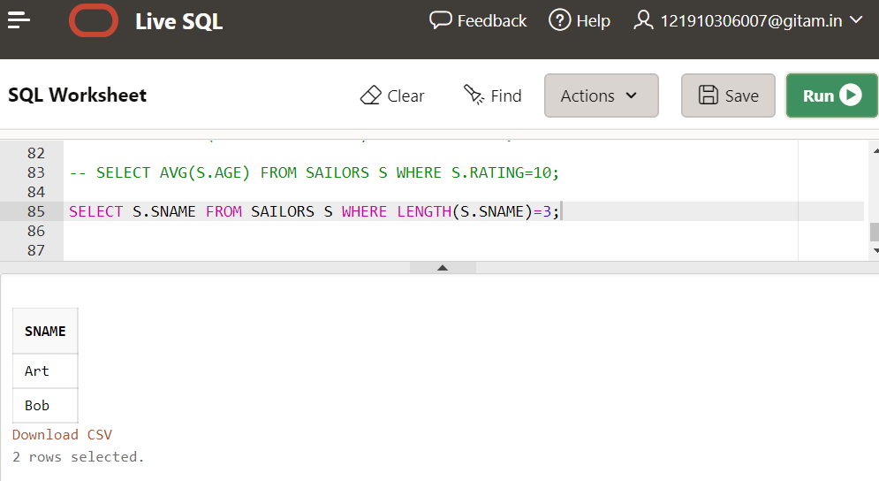

**6)Find the names of sailors whose middle letter is T?**

**SELECT DISTINCT S.SNAME FROM SAILORS S WHERE**

**S.SNAME Like '%t%';**

**Output:**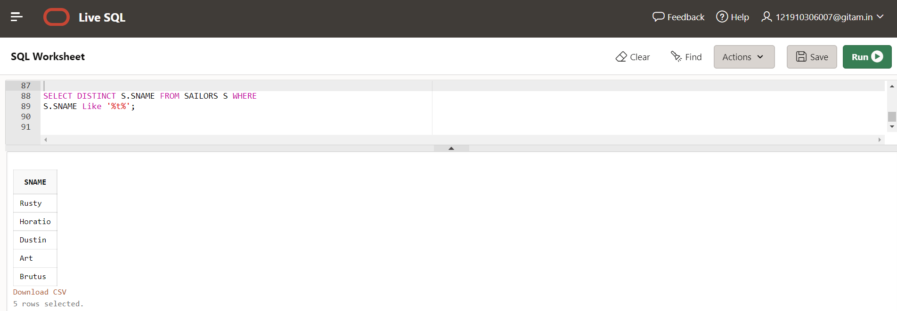

**Group By Clause**

1. **Find the age of the youngest sailor for each rating level?**

**SELECT S.RATING,MIN(S.AGE) FROM SAILORS S GROUP BY S.RATING;**

**Output:**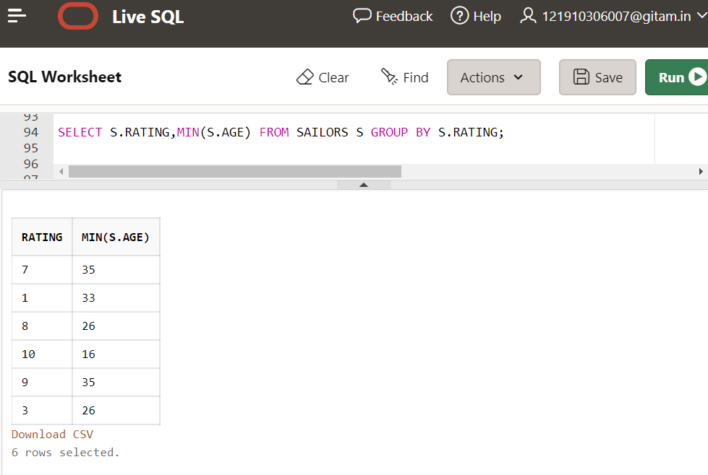

**2)Find the age of the Youngest sailor who is eligible to vote for each rating level with atleast two such sailors?**

**SELECT S.RATING,MIN(S.AGE) FROM SAILORS S WHERE S.AGE>=18**

**GROUP BY S.RATING HAVING COUNT(*)>1;**

**Output:**